Annexure
MoP:
HOW TO TERMINTAE THE INCOMING ILD TRAFFIC FROM One Softswitch to other SoftSwitch:-
In BSNL project we have created different TG for ILD traffic similarly we need to define the different SIP node for termination of ILD incoming traffic from other SS on different ILD trunk group.Here are the few steps to create the SIP node for ILD traffic
Double click on other SS option
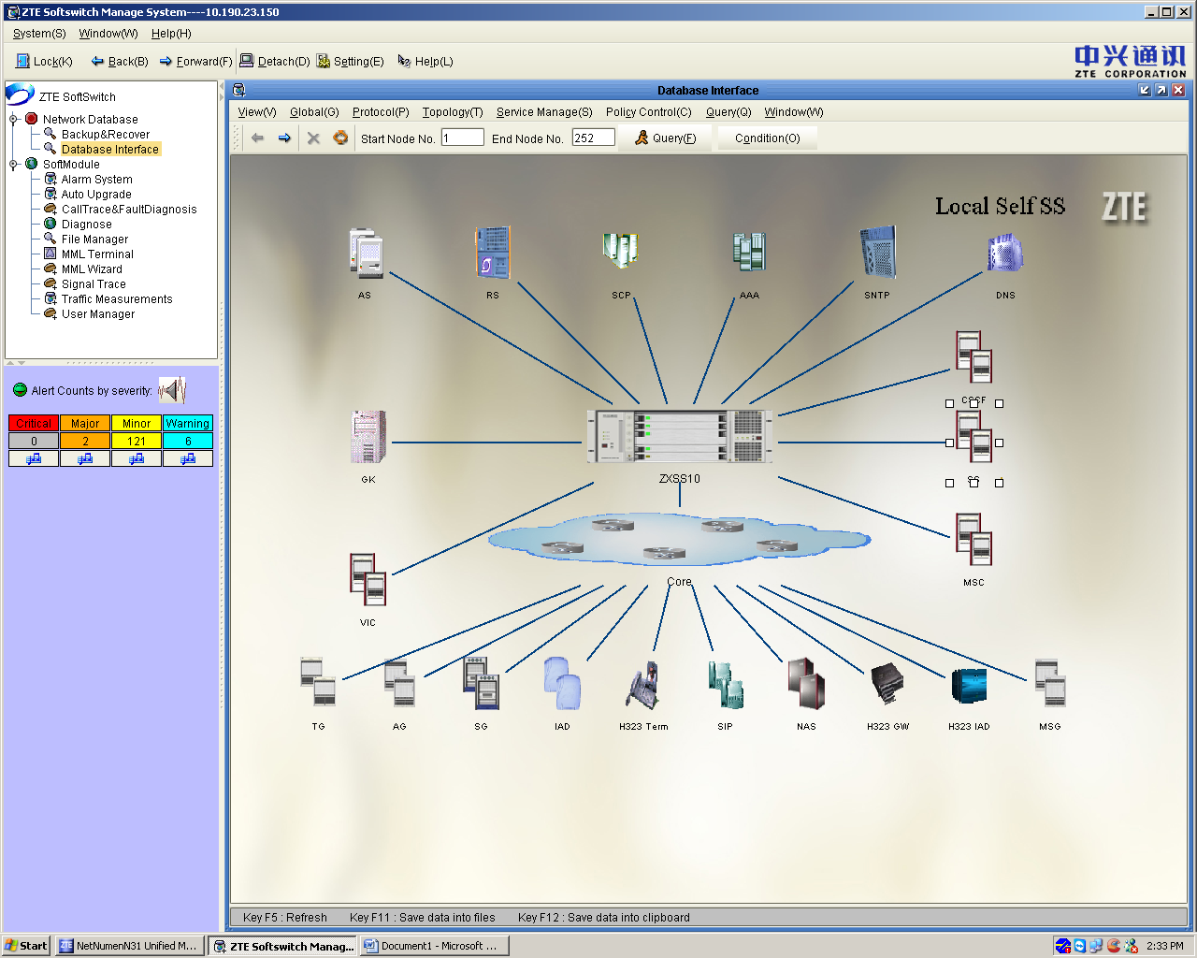
Here we need to define zone (BSNL project already created),double click on zone where we want to define ILD node
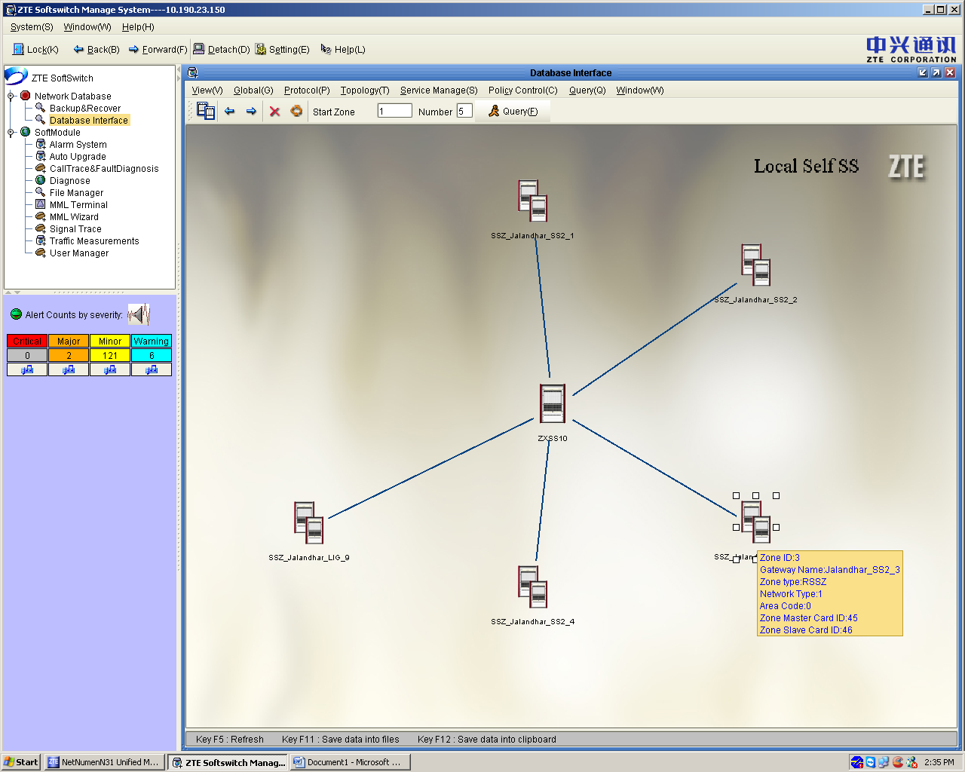
After that ,below window will appear and click on ADD SOFT SWITCH as shown below

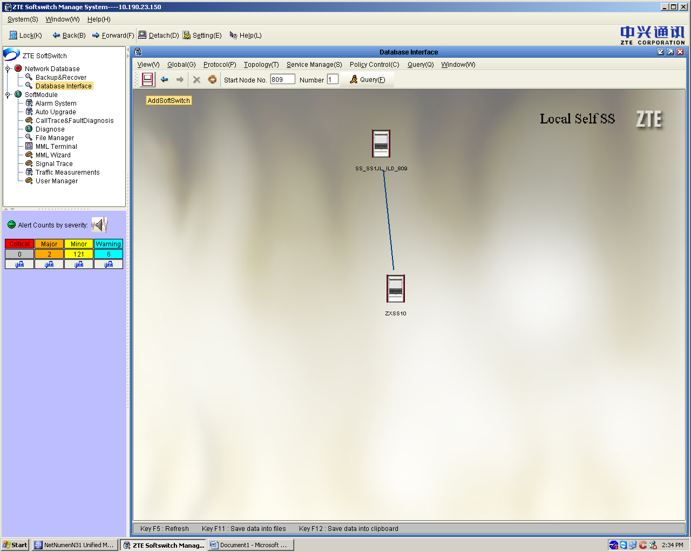

After click on add softswitch, below mention window appear and we have to define the parameters like node ID, device type-10 other ss, device IP—Ip address of other SS, device name, protocol type-6-sip,local port and peer port -5065(for ILD traffic termination we are using port 5065), port type-UDP , adscription Big capacity node—same as node id.
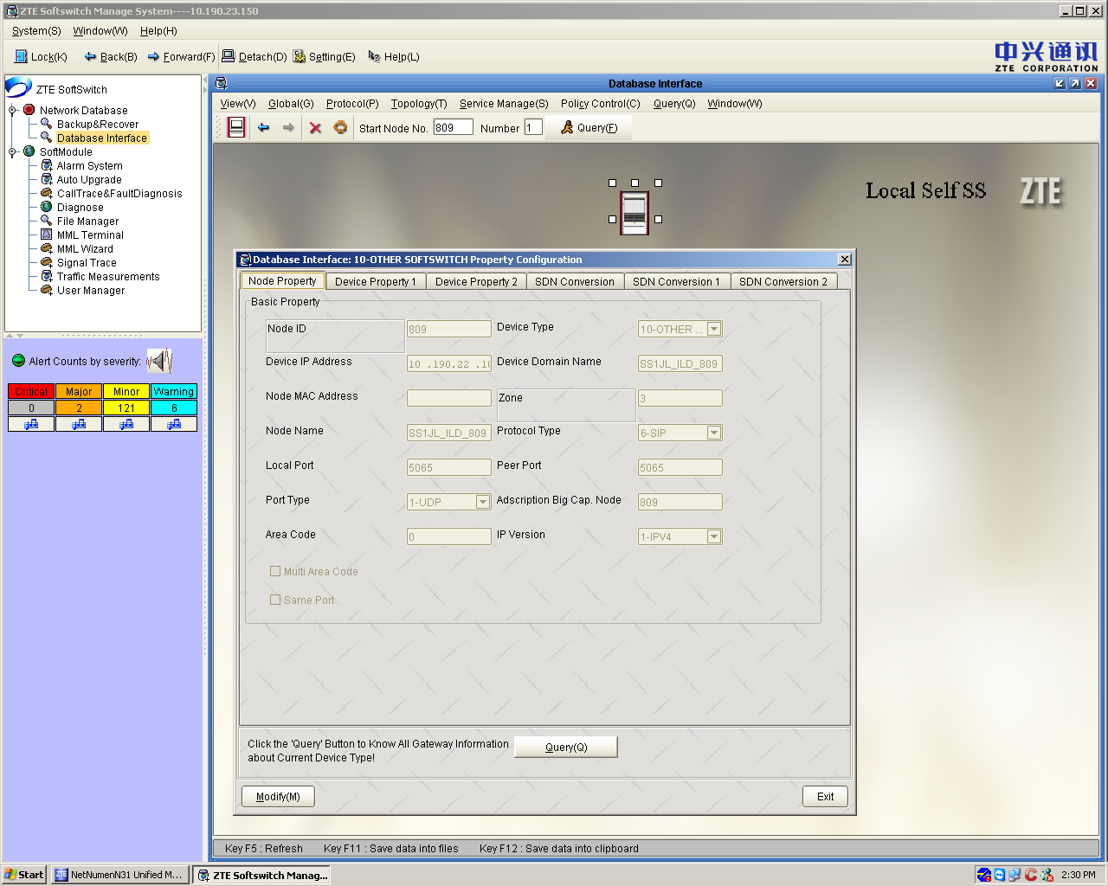
Click on device property 1
In this choose the parameter like,language type-3(for english),Time zone-The India Time,ISUP Version-3-ITU_T92+, SIP message type-2-sip invite with ISUP and SDP,SIP gateway mode -2,others are by default.
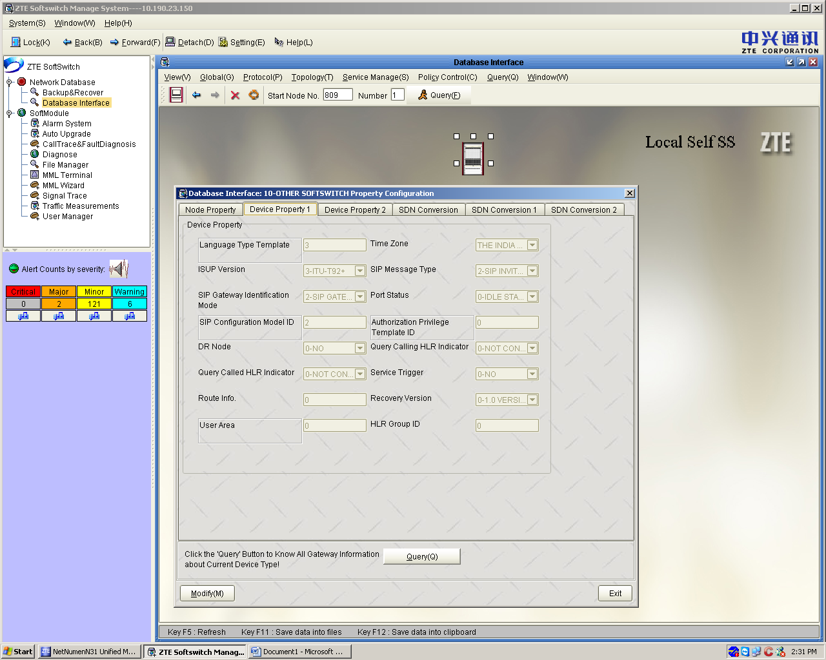
Click on Device property 2 and select BIGNode
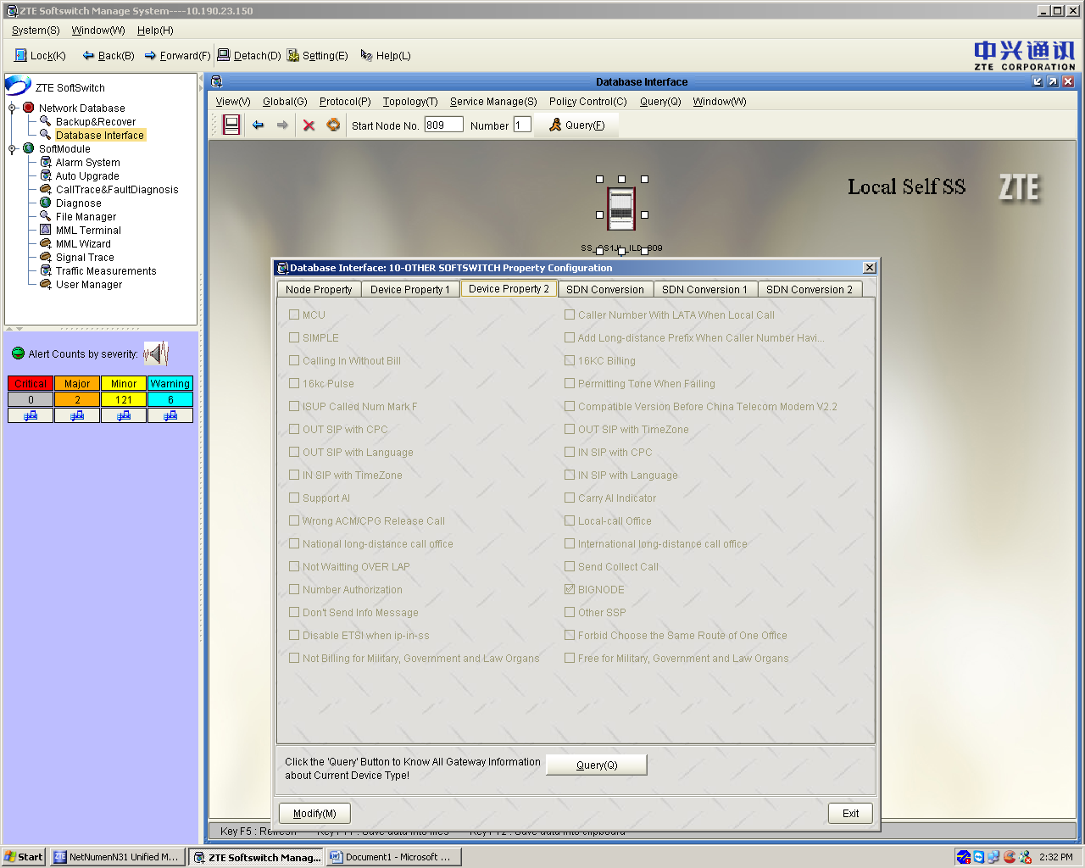
After that click on SDN conversion→Here we have defined the DAS, where we want to terminate the incoming ILD traffic from other SS. In figure it is shown TP DAS-21
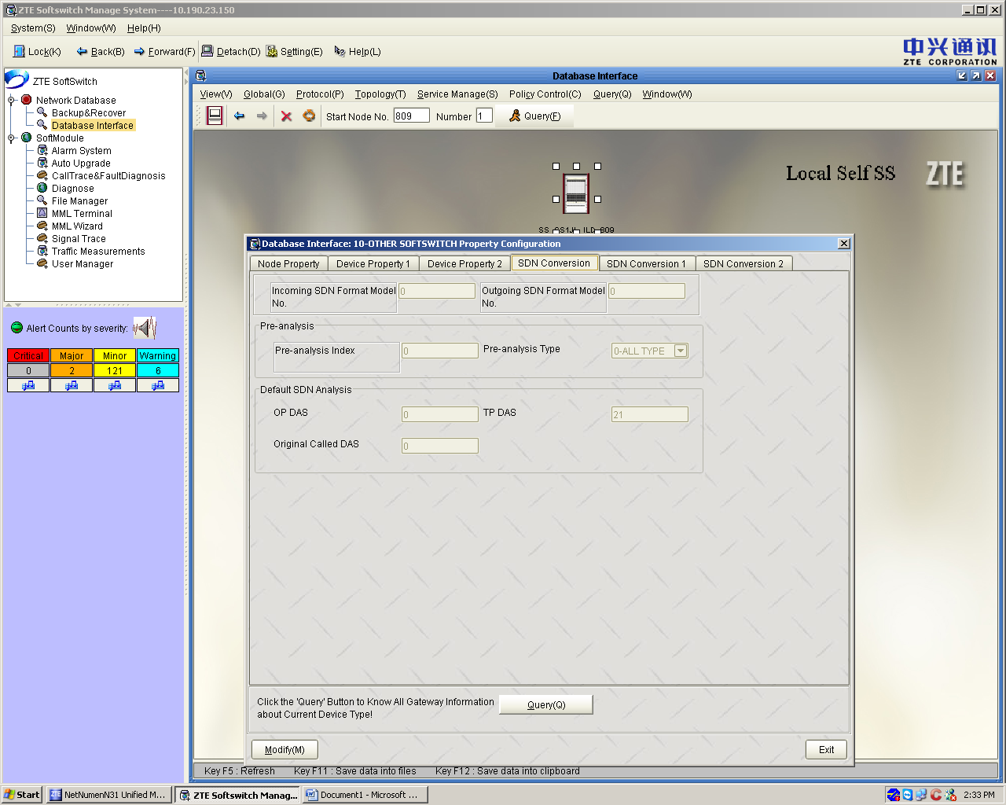

And create one NEW DAS for incoming ILD traffic as shown below,route the traffic according to your requirement.


